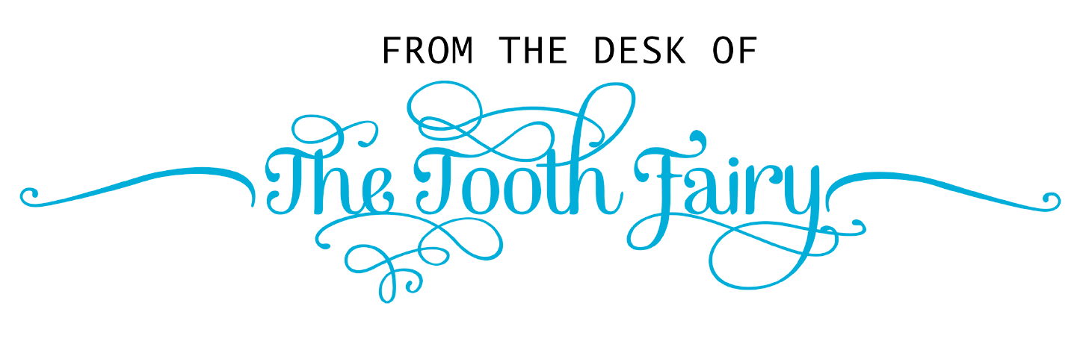Dear Preston,
I am sorry for not being able to take your tooth this morning. I know how much it meant to you. I tried to come earlier but your beautiful Rottweiler started barking at me and then I heard your dad coming down the hallway. I tried to come back in the early morning, but I didn’t realize you would be awake so early. I saw you crying and I really wanted to show you that I didn’t forget, but I couldn’t because I would have gotten in trouble with the head tooth fairy.
I came today to get your tooth and want you to know this tooth will always be special to me.
Darlene
The Ramona Fairy

